4th April 2016

**YOKOHAMA help at Düsseldorf Botanical Gardens**

The beautiful Botanical Gardens in Düsseldorf benefitted from the efforts of members of staff and management of the Japanese Tyre Manufacturer YOKOHAMA.

At the weekend, a group of volunteers from the company spent hours clearing up and beautifying several areas within the facility. A large area was carefully seen to and included the removal of weeds and dead roots and a general cleanup. Additionally the ever important area around the sprinklers on the greens, also received plenty of attention, to ensure the equipment works perfectly and not affected by grass and dirt which may block them.

The maintenance of the gardens is conducted regularly by professional staff from the Botanical gardens, who are always grateful to the International staff and Management of YOKOHAMA who supports the activity and have done so over the years as part of their community involvement and environmental initiatives.

With so many special trees at the Gardens, another good contribution from the volunteers was to partly dig out the soil under such trees and covered the area with wood chips. This avoids weeds growing under the trees and lightens the maintenance of the garden.

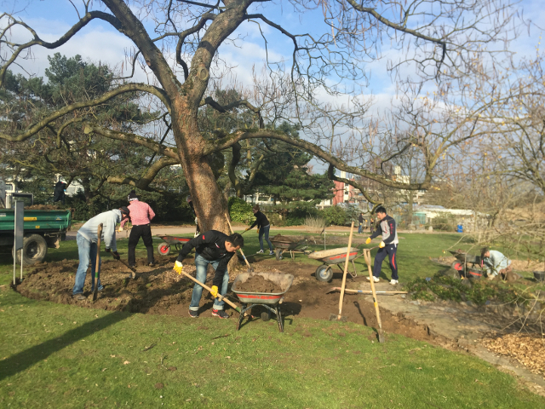

*YOKOHAMA help at Düsseldorf Botanical Gardens_1*

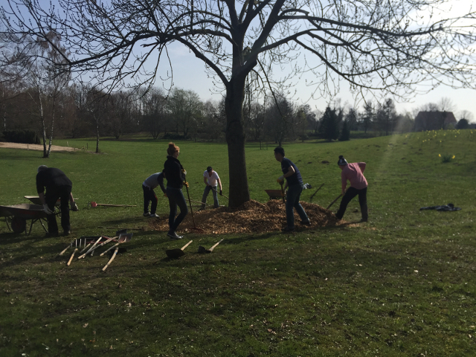

*YOKOHAMA help at Düsseldorf Botanical Gardens_2*

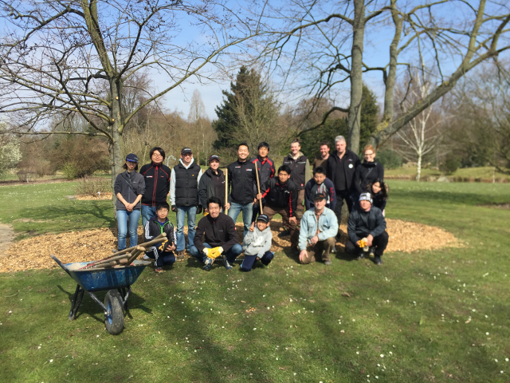

*YOKOHAMA help at Düsseldorf Botanical Gardens_Group*